**11th January 2025**

Dear **Utkarsh Pratap Singh,**

We are pleased to offer you the post of **Software Developer Trainee** with Gemini Solutions Private Limited as of **11th January 2025** and you will report to us on **20th January 2025** post which we shall make your final assignments. In addition to the duties that were outlined during your interviews, you shall perform such other duties as are customarily associated with such position and as the Board of Directors, or its authorized representative may from time to time require. You shall devote your full business efforts and time to the company and agree to perform your duties faithfully and to the best of your ability. **You agree not to engage in any other employment, occupation, or consulting activity for any direct or indirect remuneration without the prior approval of your supervisor.**

To address and appropriately deal with any instances or behavior that comes under following clauses, Zero Tolerance Policy (ZTP) (which includes immediate termination) is applicable to all employees of Gemini Solutions:

1. Demonstrate non-professional behavior/attitude towards customer/ clients.
2. Usage of profane, vulgar, or abusive language.
3. Offensive or inappropriate references to Race, Ethnicity, Religion, Gender, Lifestyle, Sexual Orientation, Disability and Age.
4. Consistent interruptions in a rude and sarcastic manner with client.
5. Unauthorized release of confidential information.
6. Inappropriate fraternization with clients.
7. Coming to work intoxicated or any disciplinary issues on the floor.
8. Extended unscheduled breaks, unapproved/ unscheduled leaves, reporting late to work etc.
9. Disparaging remarks about Gemini Solutions or Clients.

If the ZTP Committee decided to terminate the concerned employee immediately, then the standard full and final procedures are followed after the due consideration depending on seriousness of issue.

You understand and agree that neither your job performance nor promotions, commendations, bonuses or the like from the Company give rise to or in any way serve as the basis for modification, amendment, or extension, by implication or otherwise, of your employment with the Company.

You will be compensated **Rs.15,500 (Fifteen Thousand Five Hundred only**) per month for the work performed during the training. You will be paid in accordance with the company's normal payroll practices and be subject to the usual, required withholding.

**While employed hereunder, you will not be entitled to participate in the employee benefit plans maintained by the Company, if any. You will be eligible for paid leave and paid holidays only as approved by your supervisor. The company will provide you with free Lunch and refreshments as additional benefit.**



The Company will also reimburse you for reasonable and documented travel, entertainment or other expenses incurred by you in the furtherance of or in connection with the performance of your duties hereunder, in accordance with the Company's expense reimbursement policy as in effect from time to time. The company will invest a lot of time, money, and energy in training you, so it is mandatory for you to complete the training.

You acknowledge and agree that you are executing this letter voluntarily and without any duress or undue influence by the Company or anyone else. You further acknowledge and agree that you have carefully read this letter and that you understand the terms, consequences, and binding effect of this letter.

This letter, together with any agreement you enter with the Company represents the entire agreement and understanding between the parties as to the subject matter herein and supersedes all prior or contemporaneous agreements, whether written or oral. If any provision hereof becomes or is declared by a court of competent jurisdiction to be illegal, unenforceable, or void, this letter will continue in full force and effect without said provision.

No waiver, alteration, or modification of any of the provisions of this Agreement will be binding unless in writing and signed by duly authorized representatives of the parties hereto. The internal substantive laws, but not the choice of law rules, of the State of India, shall govern this letter.

If you choose to accept this offer, please sign a copy of this letter in the space. We hope that this offer will be favorably received, and we look forward to working with you at Gemini Solutions Private Limited.

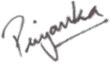Sincerely,

**Priyanka Gubrele**

**Vice President - Human Resource Gemini Solutions Private Limited**

**ACCEPTED AND AGREED:**

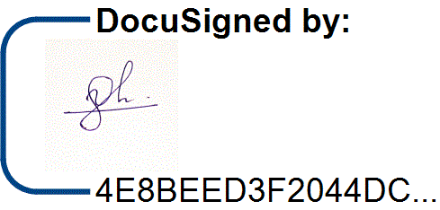**Utkarsh Pratap Singh**

Signature:

11/01/2025

Date: